Example1

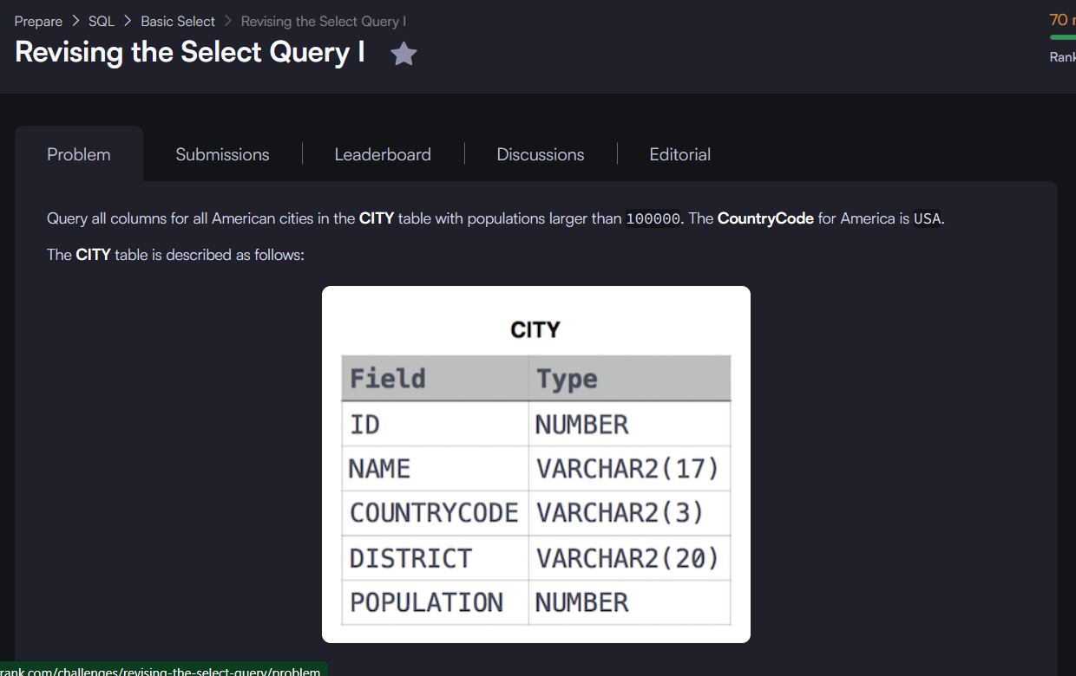



Example 2



Example 3



Example 4



Example 5



Example 6



Example 7

